# Implementation

## Recursive Function

To distribute the money according to how much money each player has put in the pot the program dequeue the first array in the playerWin queue and passes all the players in the array that haven’t folded. The recursive function then sorts by the amount of money each player has put in. It then calculates the amount of money each winner is due based on the number of winners and players in the list, and decreases the amount each player has put in. With each iteration it calls the function with one less player and deletes winners that have been dequeued from the players array. In certain situations, the total pot cannot be divided equally by the number of players. The extra chips must be shared out as equally as possible, which is what the second recursive call does

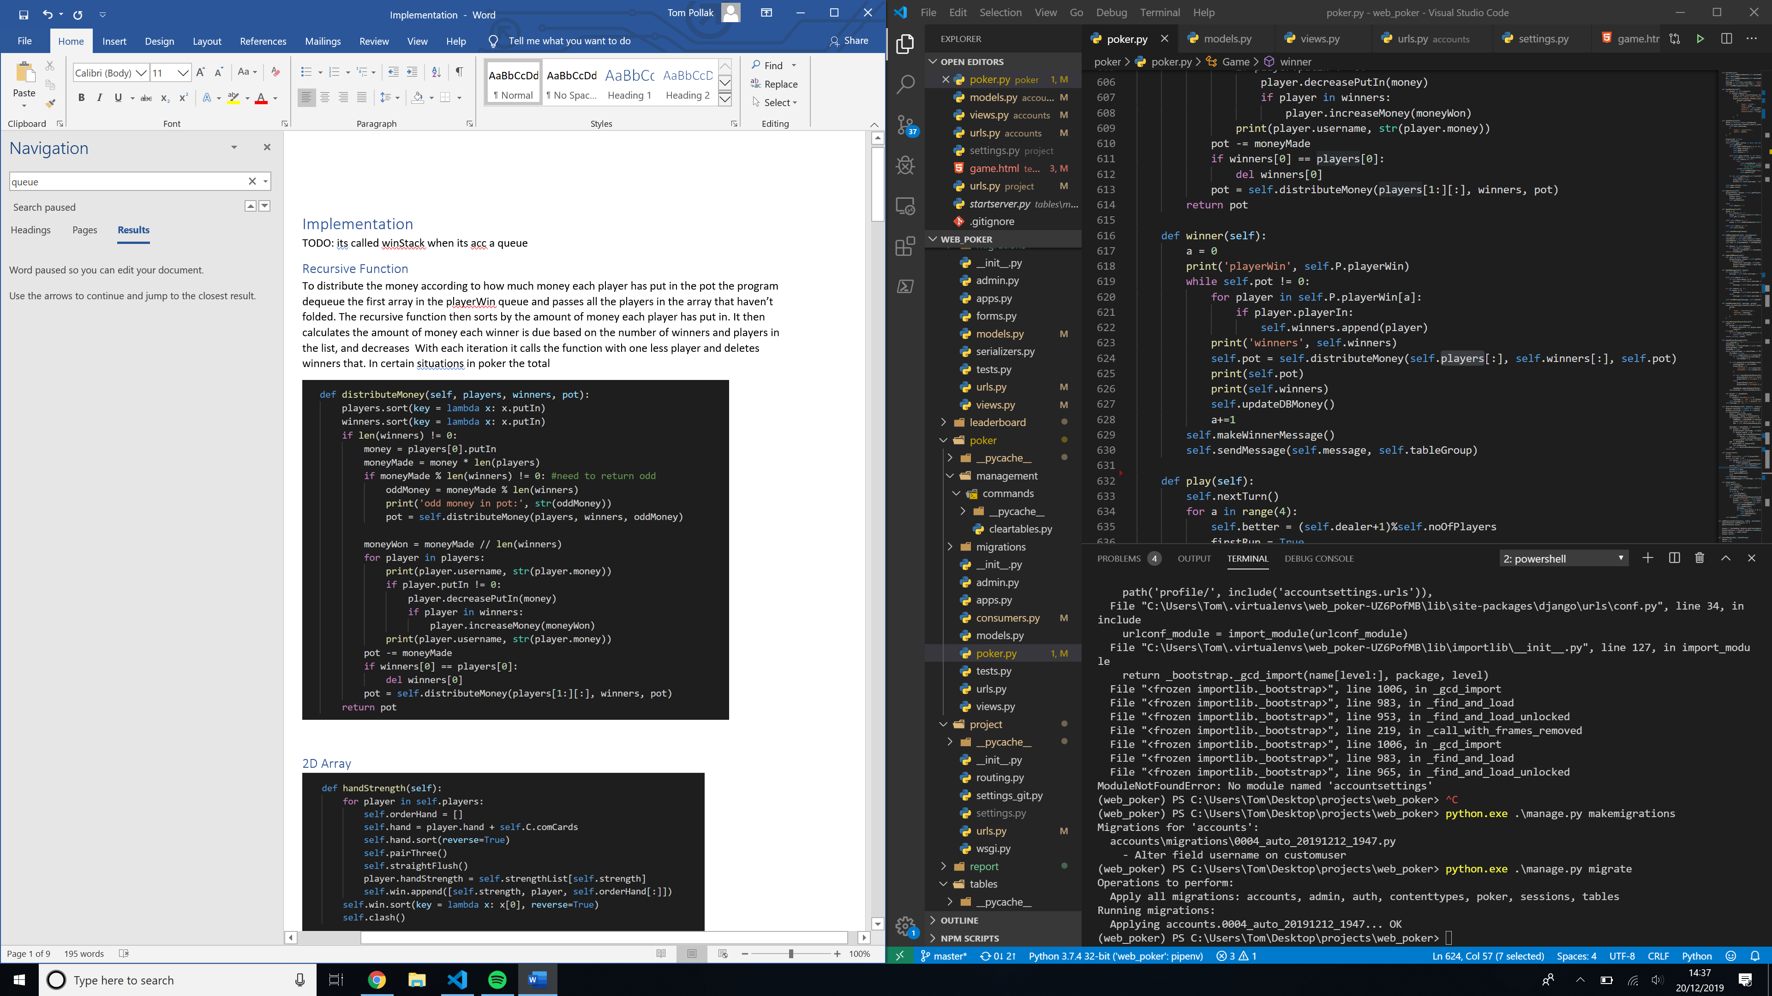

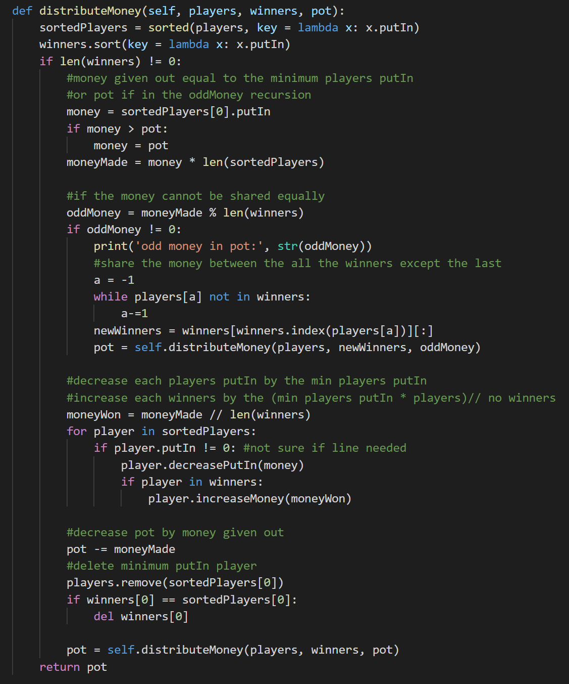

## 2D Array

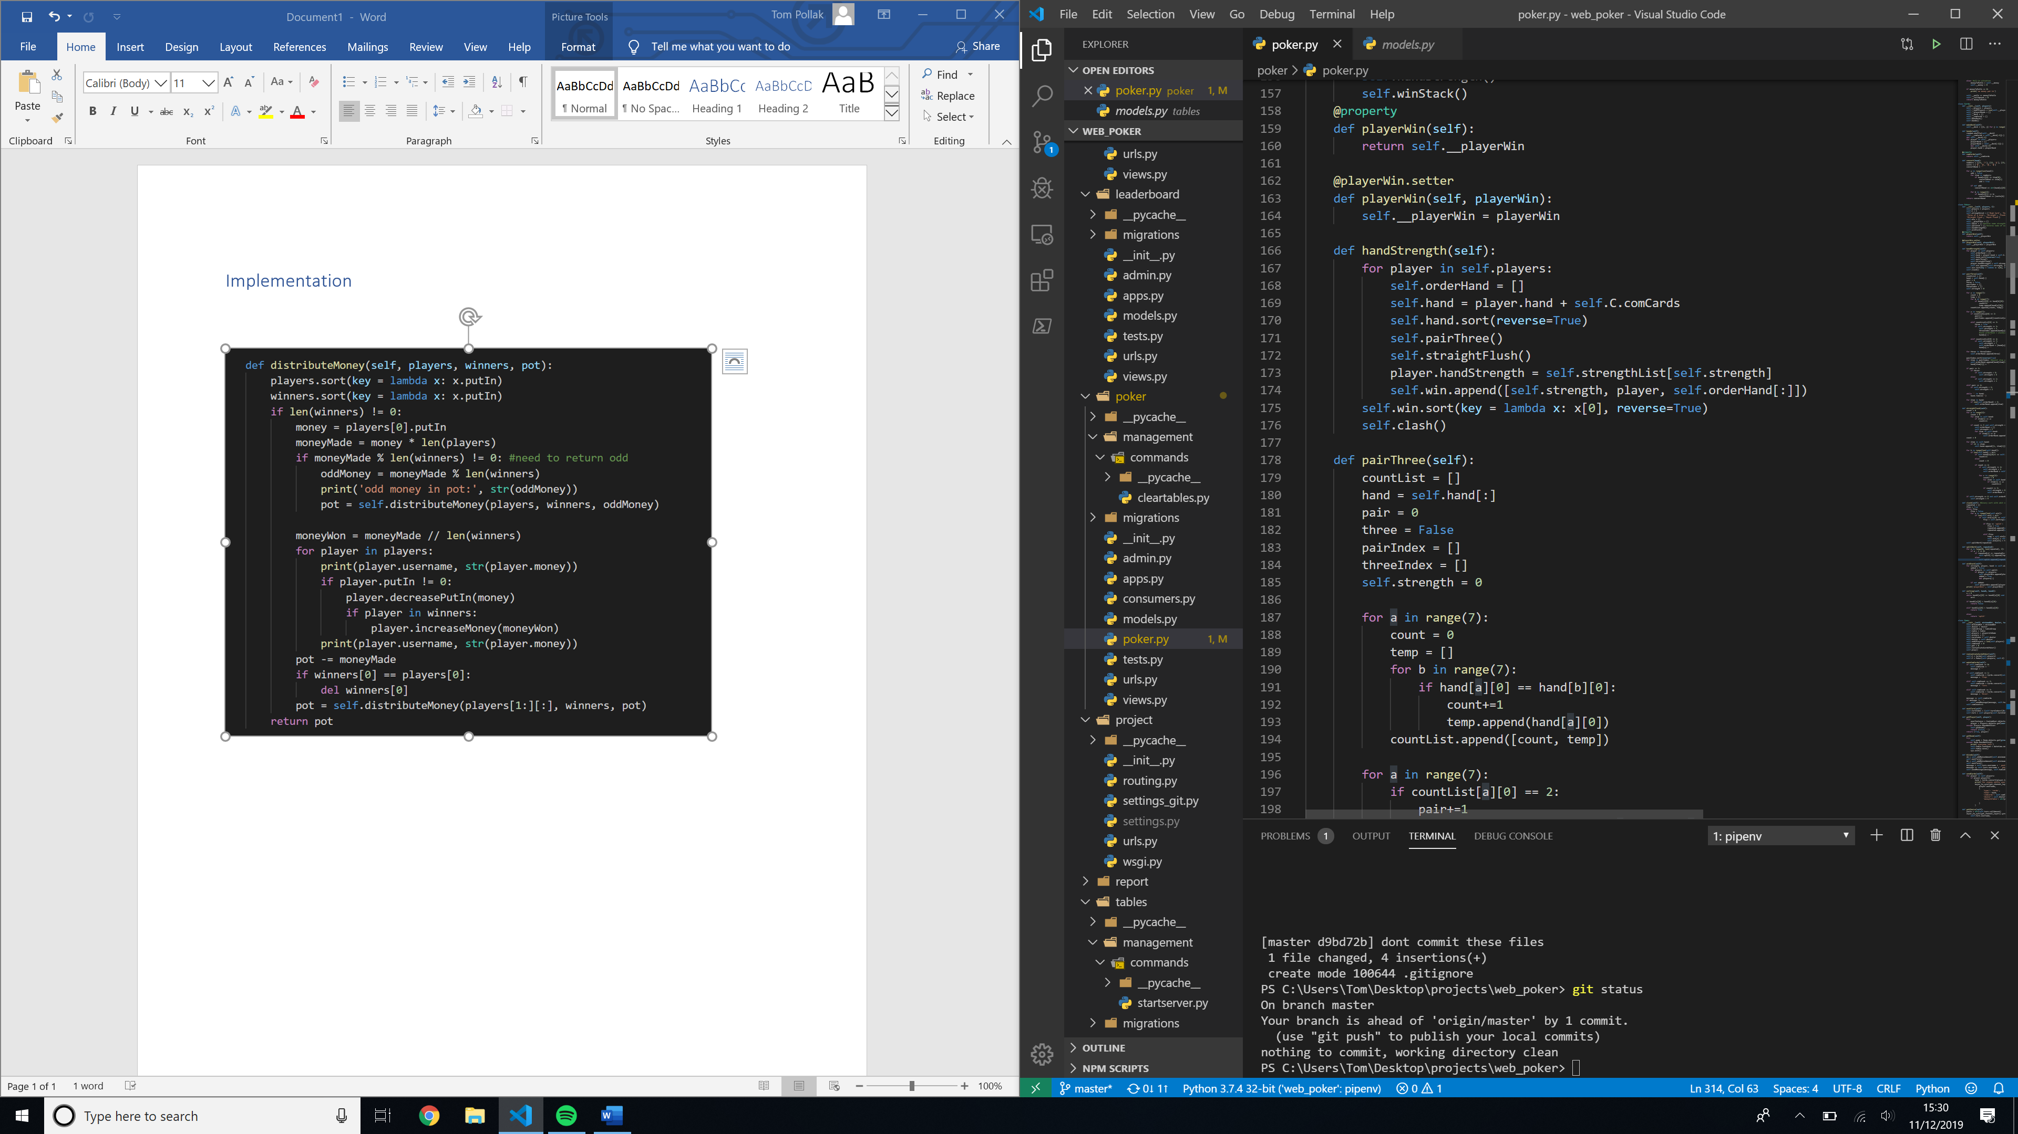

## 

## List Operations?

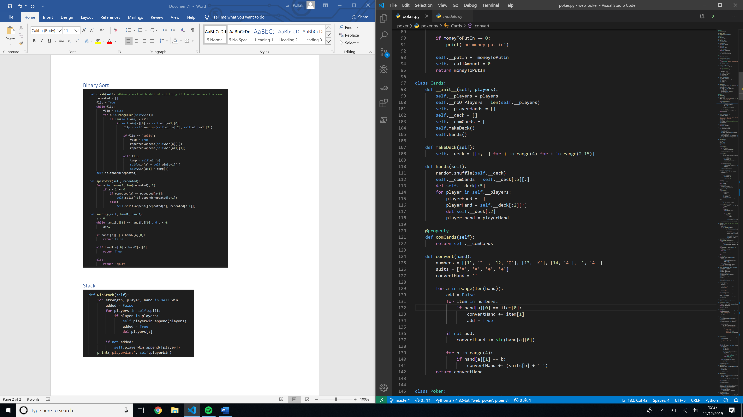

## Binary Sort

If two players have the same hand strength, the program needs to sort the cards by the ‘strength’ of the card e.g. Ace > King. The cards are already ordered so the cards that make hand strength are at the front of the hand, e.g. the 10 pair comes before the Ace. A binary sort is used to sort the hands as there will be at most 8 players in the table so the overhead necessary for a merge sort would not be efficient. If two players have exactly the same strength then the two players are appended to the split array in an array.

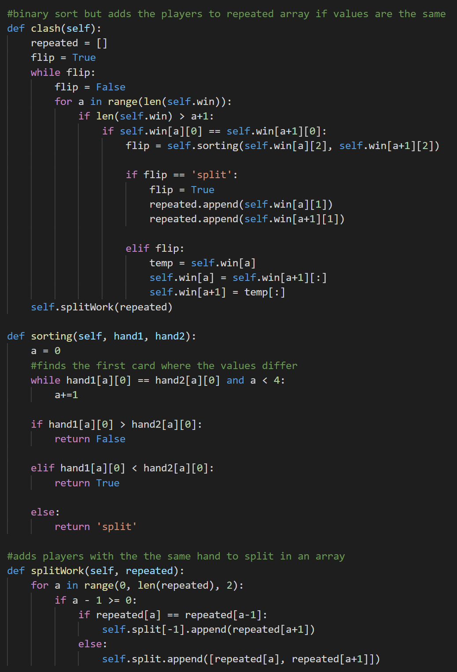

## Queue

From the sorted array created by the binary sort the player object from each hand is appended to the playerWin queue in an array. If the player object is in the split array (aka the player has the same strength as another player and so would share the pot if won) the split array is appended to the win queue. (This is why the player object is appended in an array in first part so all the player objects are 2 layers deep).

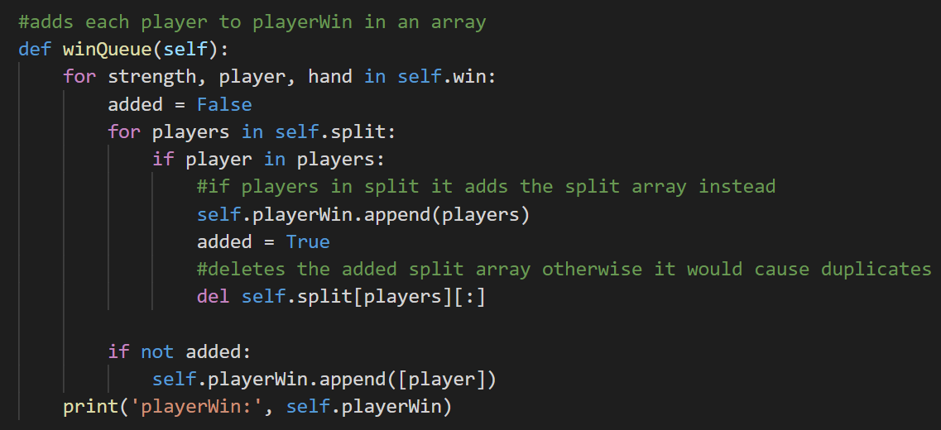

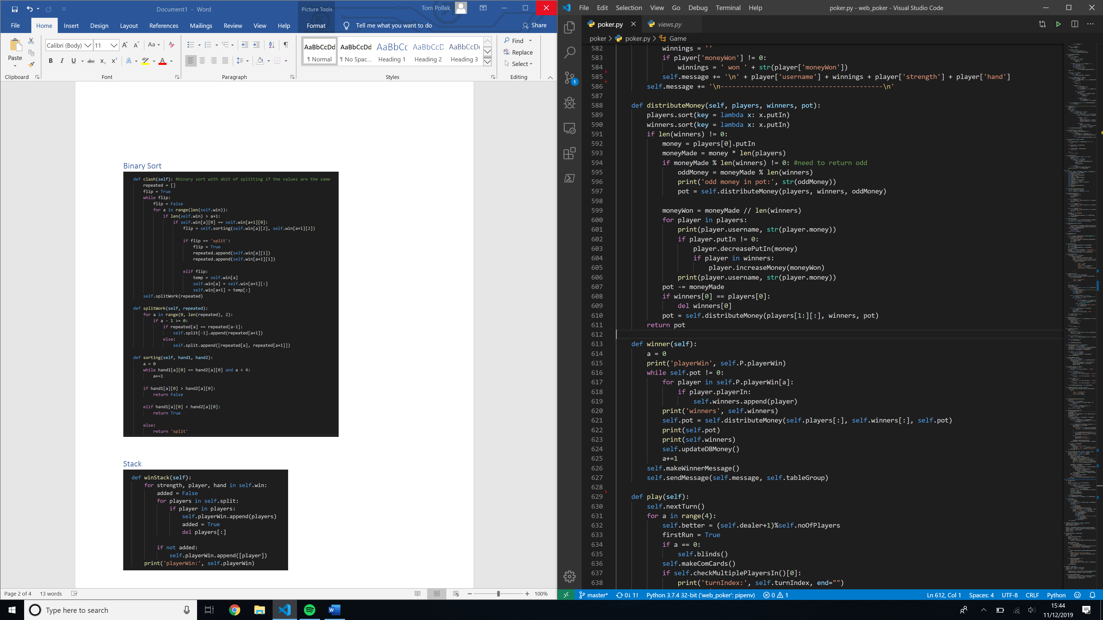

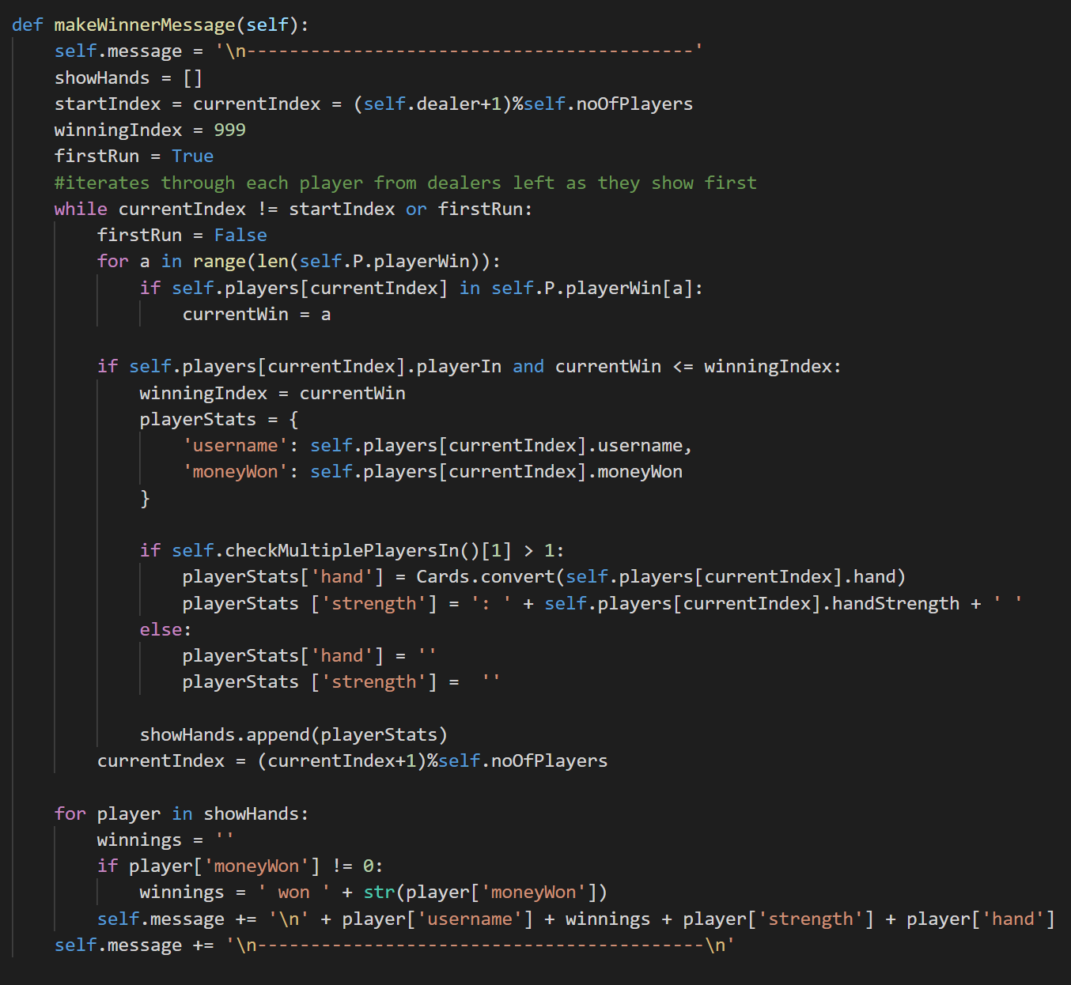

## DB Objects

In Django, DB records can be modelled as python objects. Each DB table is represented as its own class.

### Creating DB Objects

Each variable represents a row of the table. The **Table** object can also reference the **Room** object because there’s a one-to-one relationship between the **Table** and the **Room**, as instantiated in the **Room** object. DB classes can also contain methods that can be run on the data in the table. For instance, the **Room** table contains the number of players in a table. However, the **Room** object only exists while players are in the table. So, if the table has no players in it, trying to get the number of players in the table will return an error.

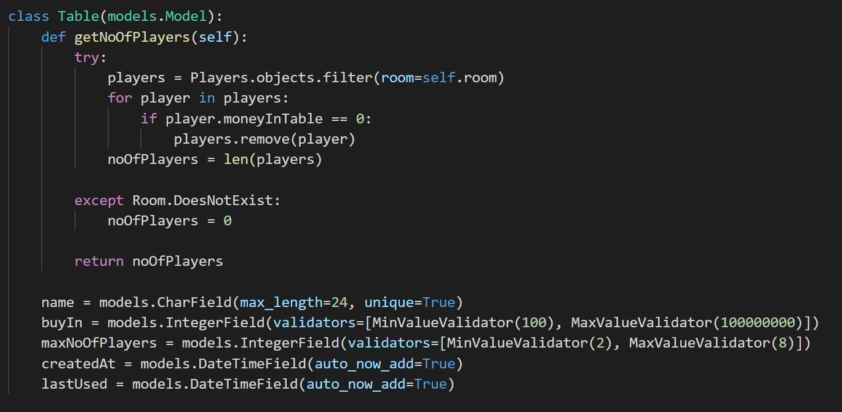

### Instantiating DB objects and records, getting DB objects

After the incrementing the **Room** noOfPlayers record, the function gets the players user data from the database using the players username. Getting an object is similar to WHERE in SQL syntax, however must only return one DB object. It then creates a new DB record using the **CustomUser** object and the **Room** object. This is stored as a one-to-one relationship with **CustomUser** and a foreign key with **Room**.

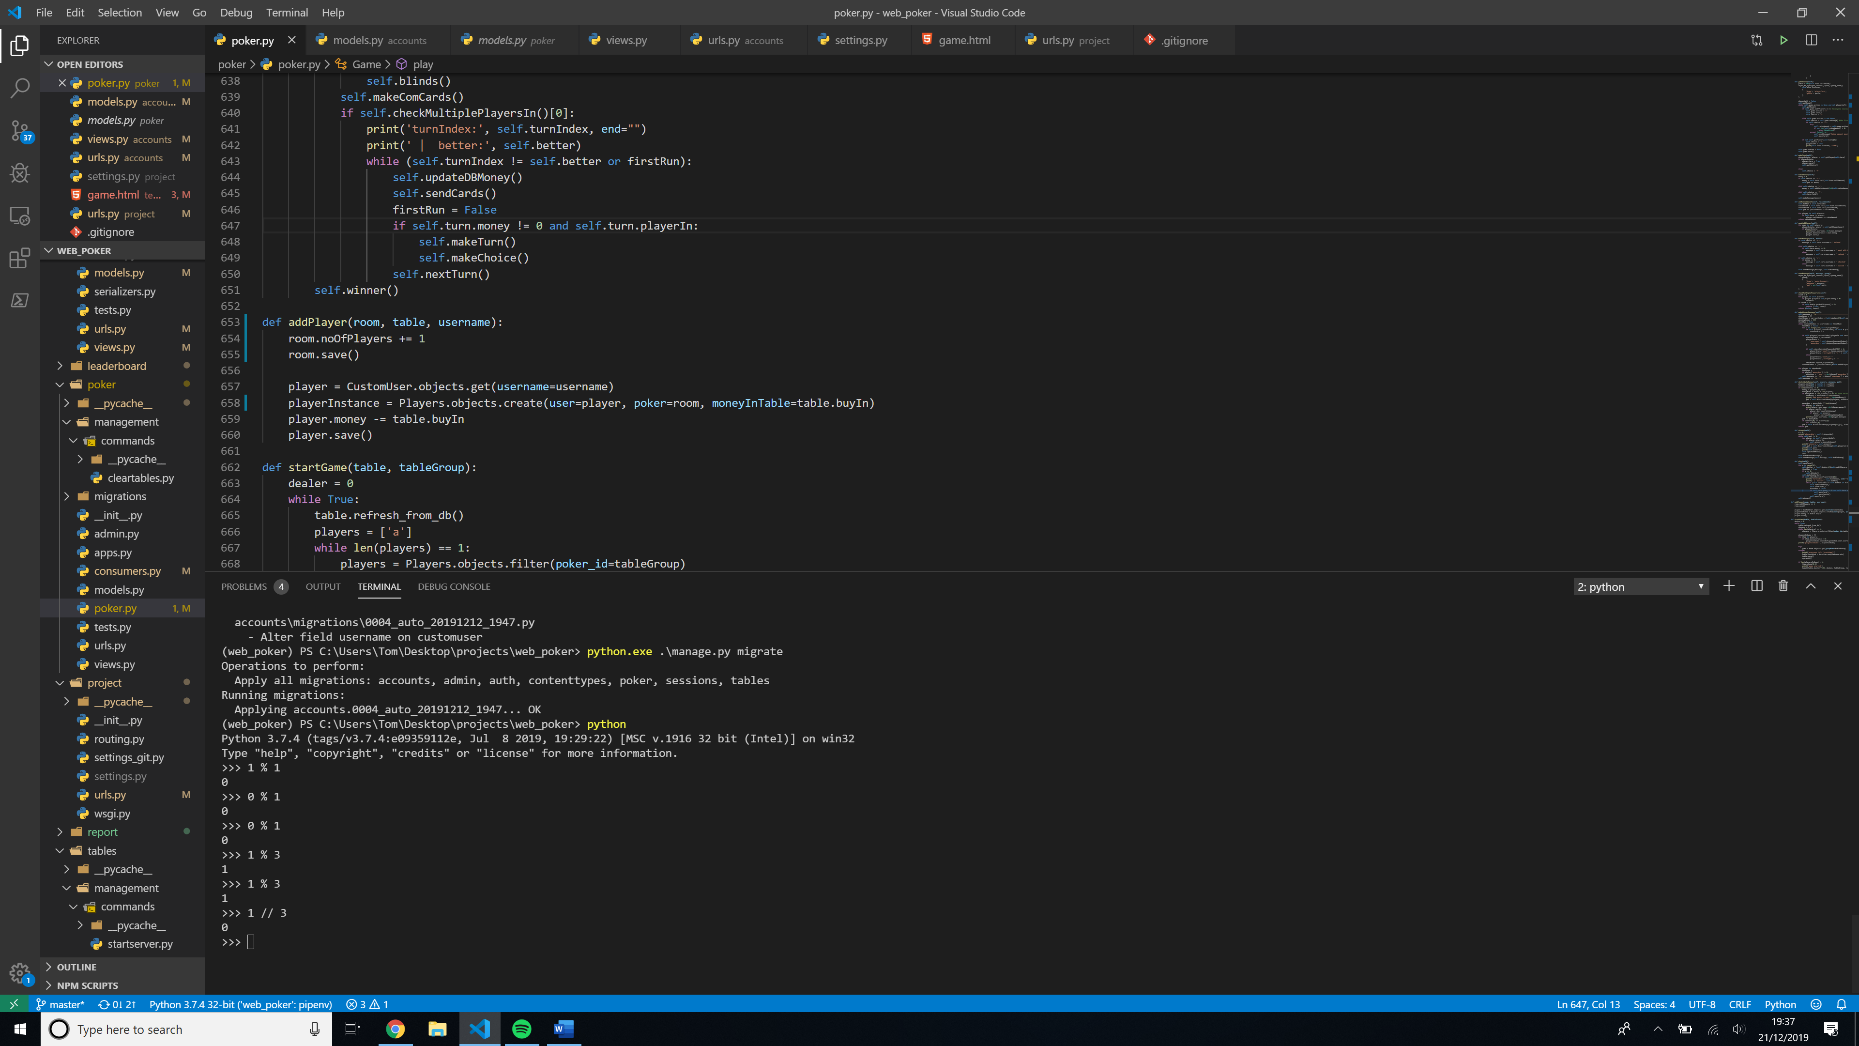

## Threading

### Creating thread

The view function has a @login_required decorator, which means that only logged in users can access the function. If the user has the minimum required money to join the table and the table is not full it starts a daemon poker thread. A daemon thread just runs in the background so the view can return and the program can end to accept more web requests without the daemon thread ending.

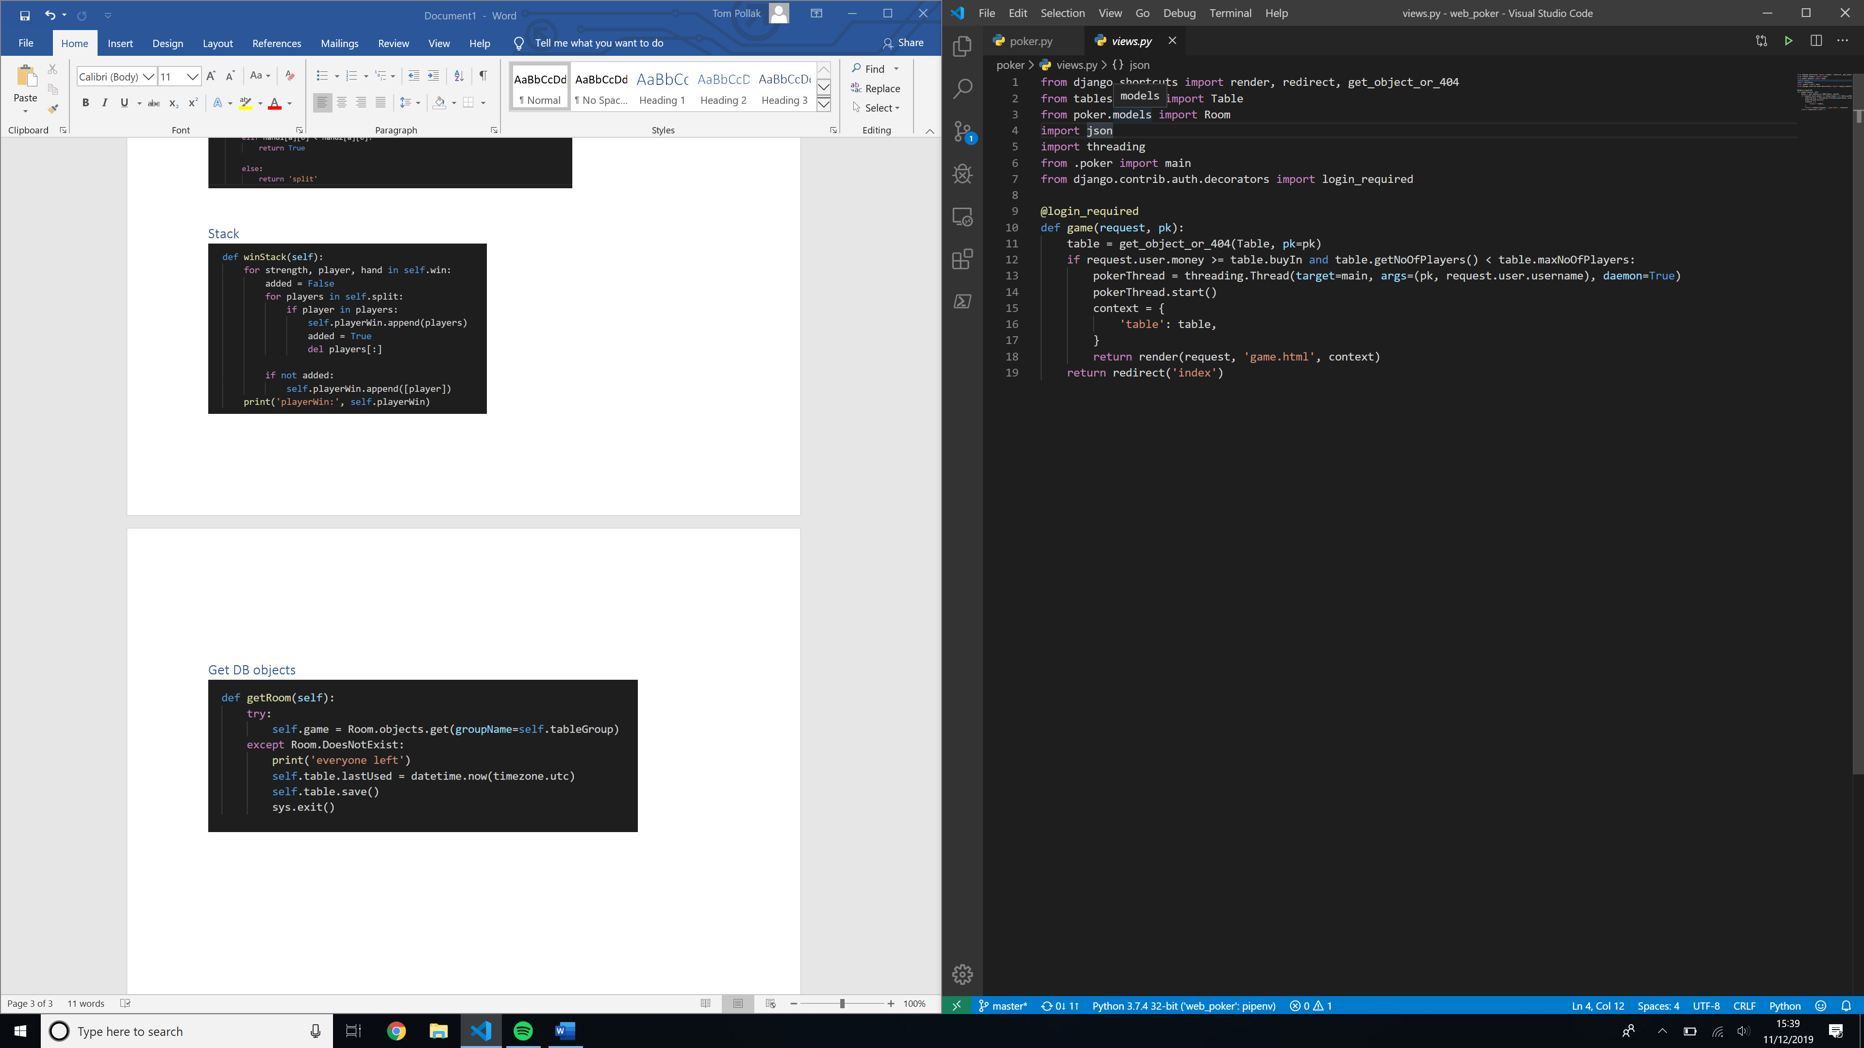

### Thread function

The function checks for an active **Room**. If a room is found, it adds the player and exits. If the **Room** doesn’t exist, it creates one adds a player to the room and starts the game.

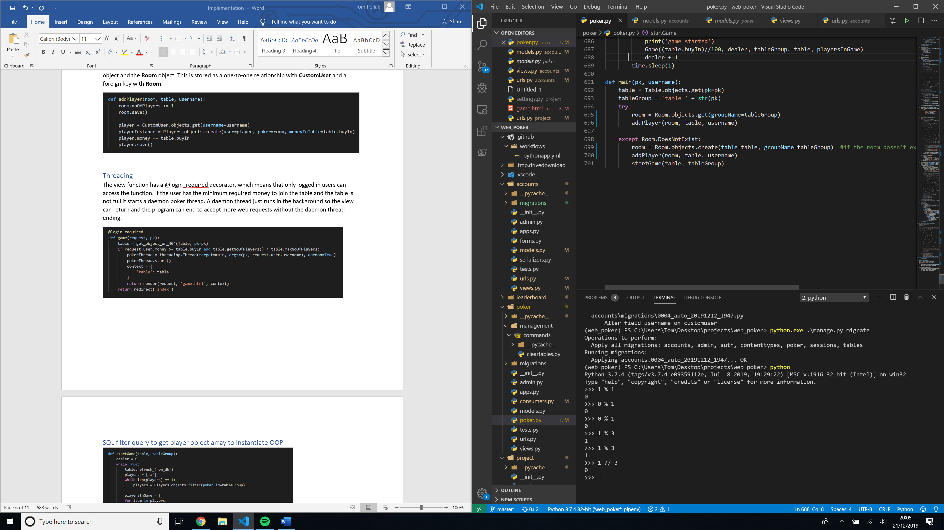

## SQL filter query to get player object array to instantiate OOP

Function runs in an infinite loop starting the next poker round when one finishes.

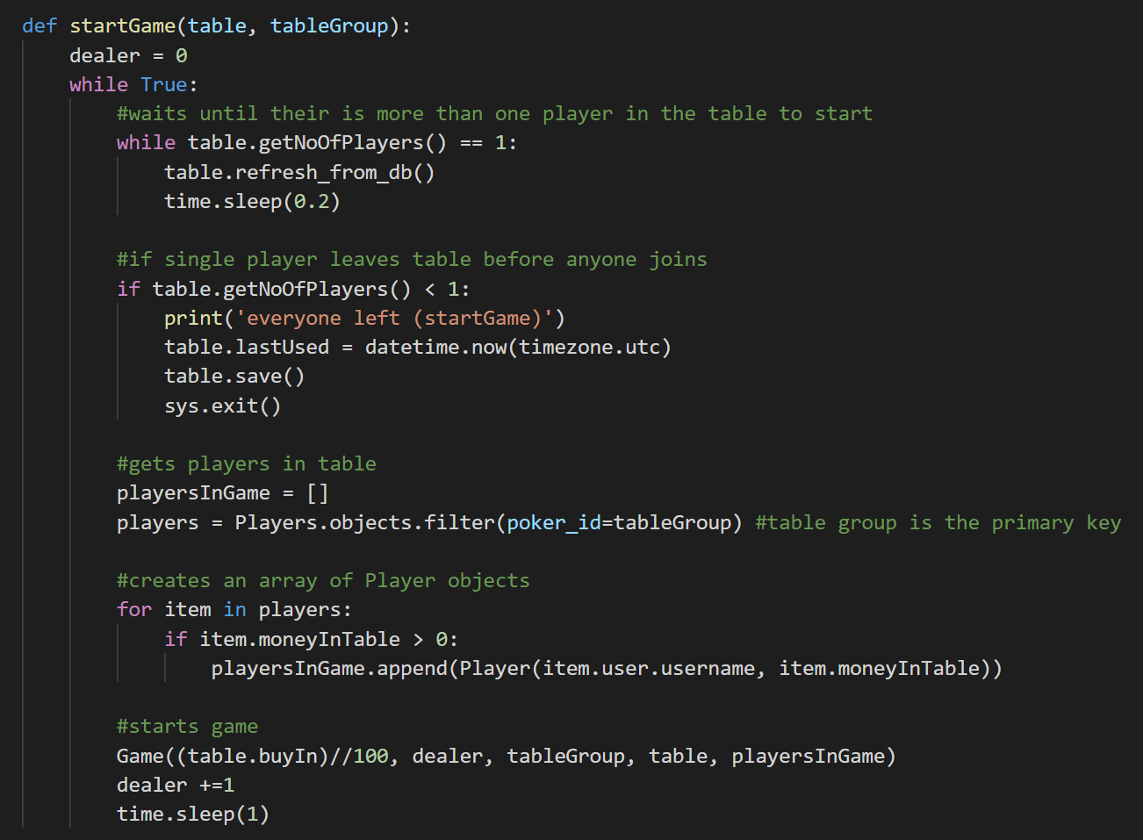

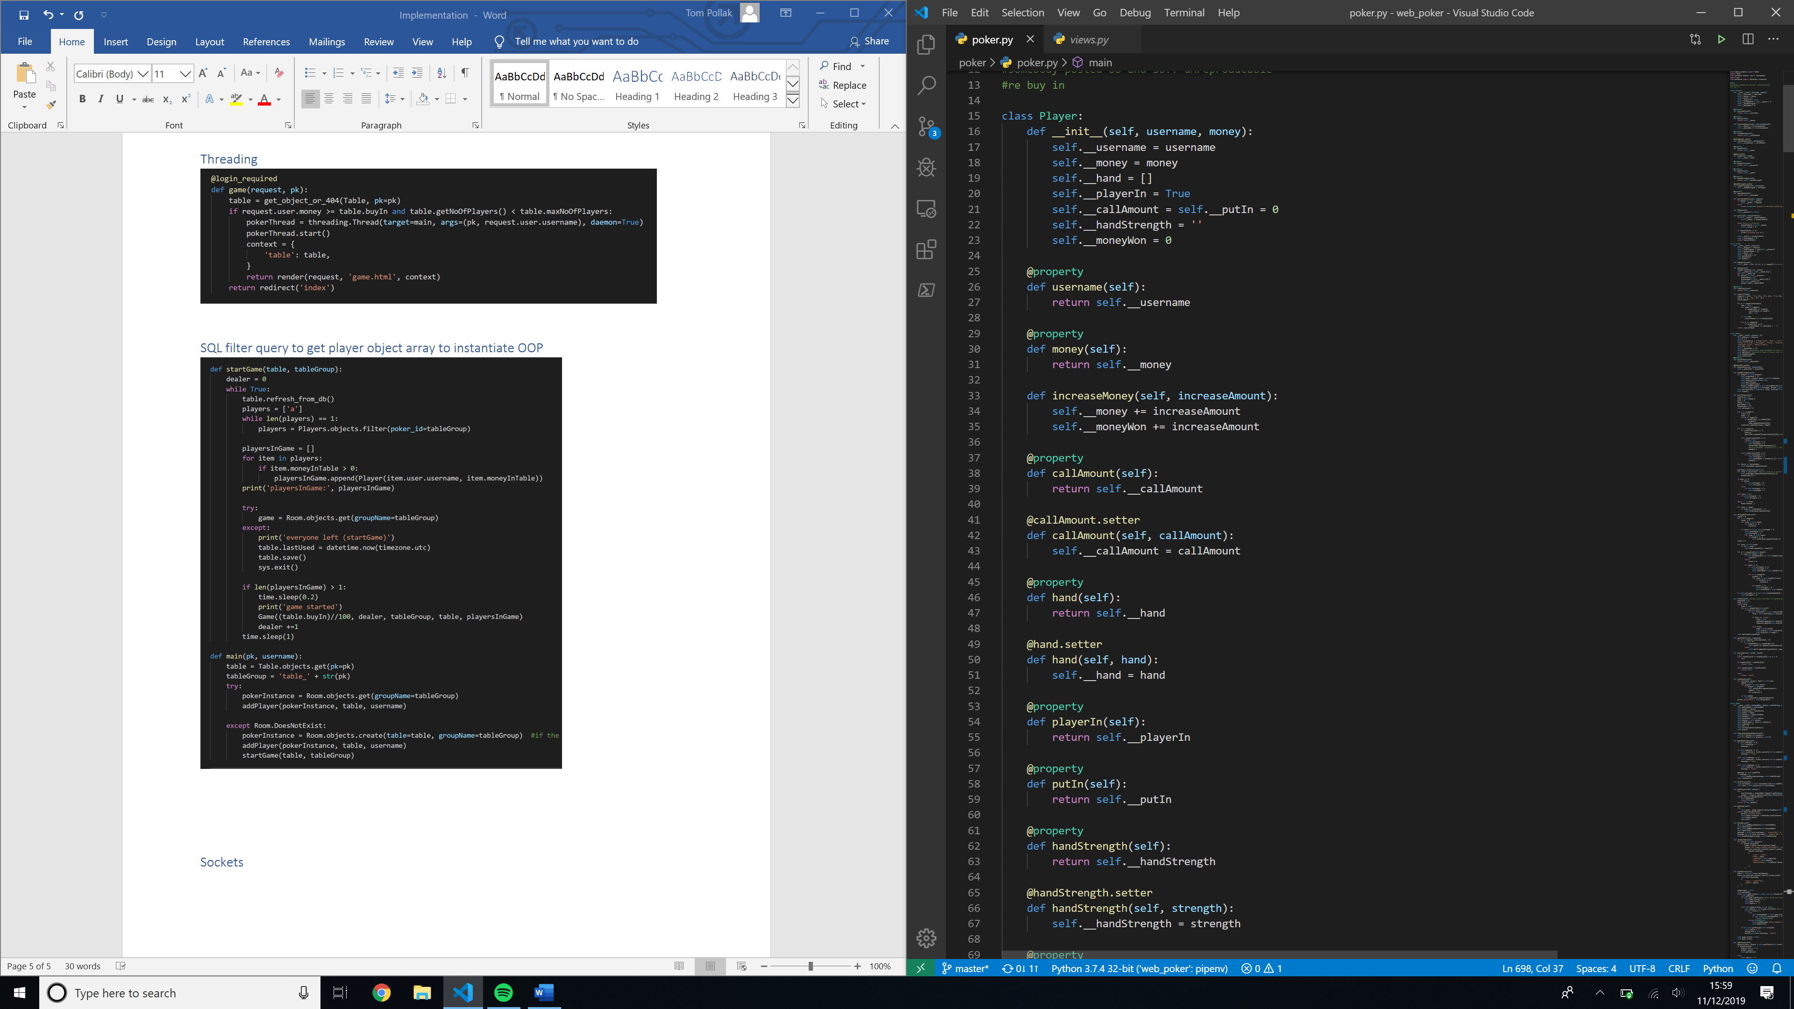

## Synchronous web sockets adding user to poker room group socket and personal web socket

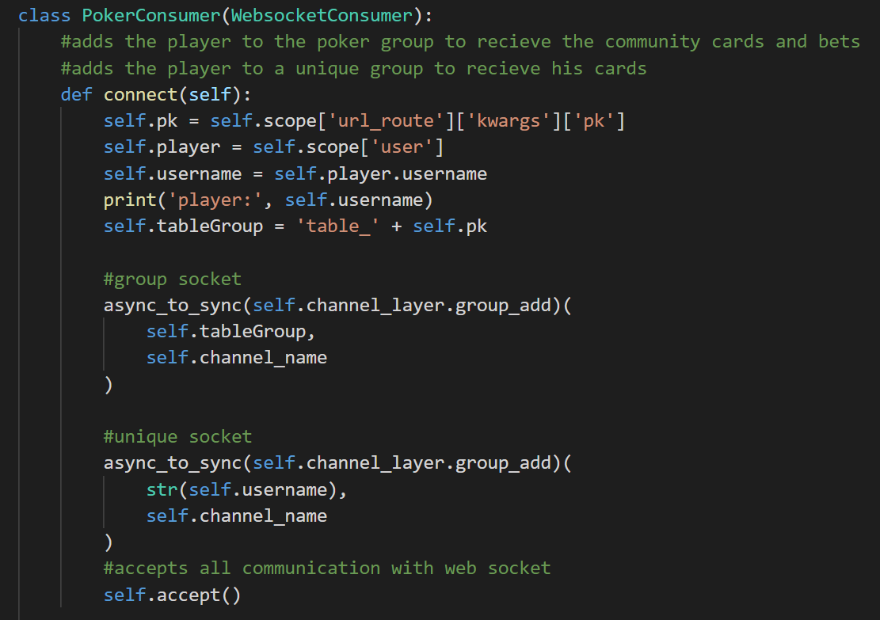

## DB Model

As DB models are python objects, they can contain python methods to interact with the data

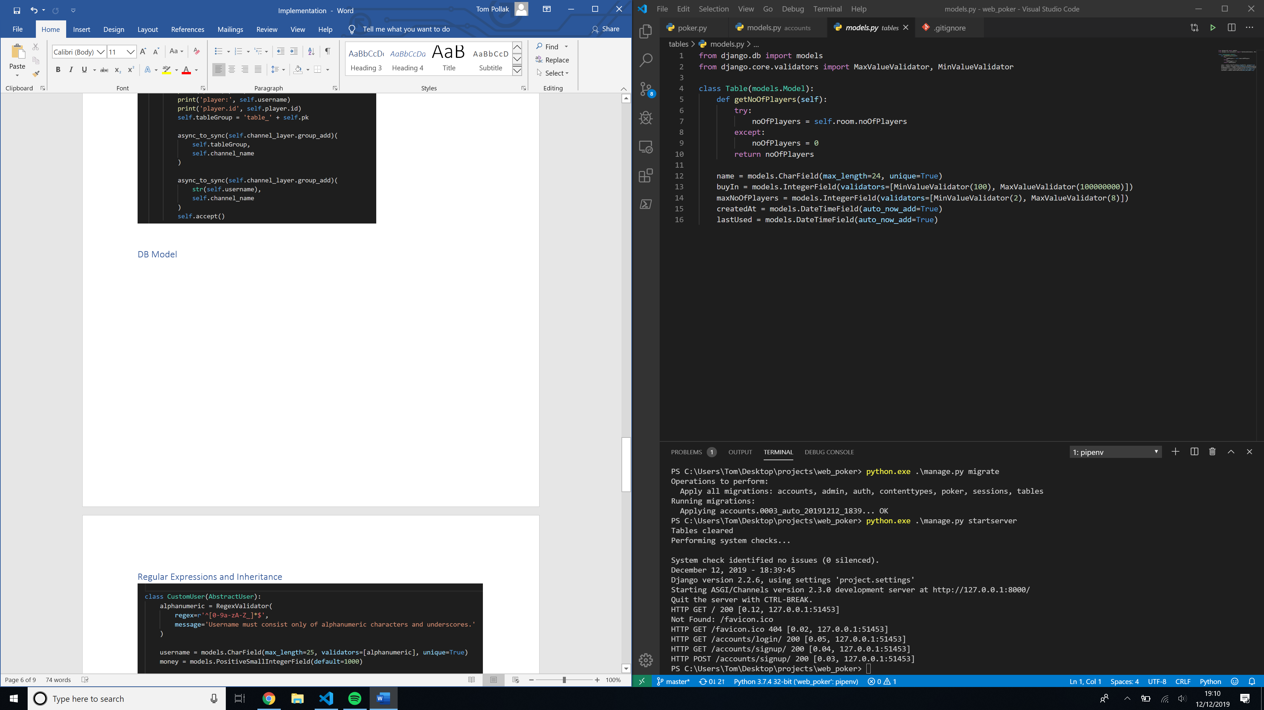

## Regular Expressions and Inheritance

The user model inherits from the default AbstractUser class that comes default with Django, containing default user characteristics such as username, password. The regex expressions checks that the username is alphanumeric as the username is used for the players unique socket name which must be alphanumeric

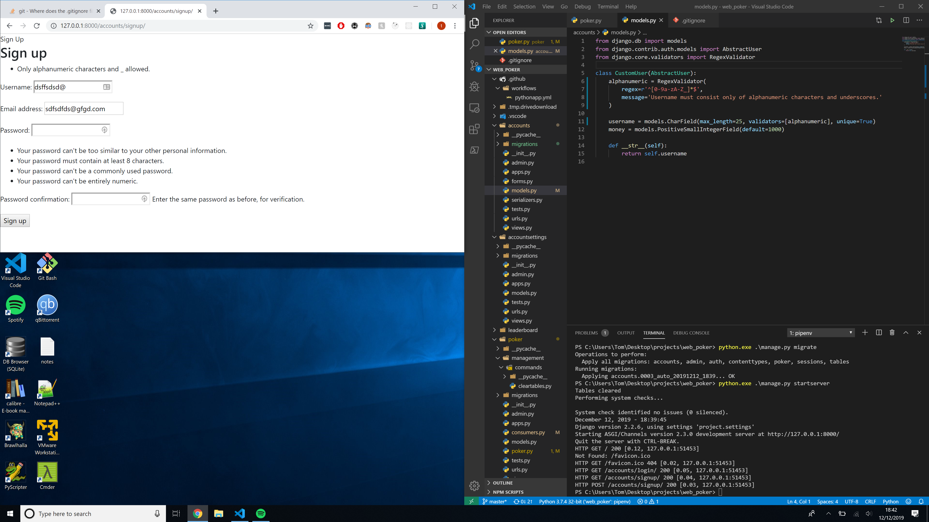

## Exception handling and getting and setting private variables

A property decorator works so that you can use the property function to get the value like a variable, it must return a value. It is equivalent to a getter. A setter function is called when you attempt to set the property function. It verifies that the input is valid and sets the value or raises an exception if not.

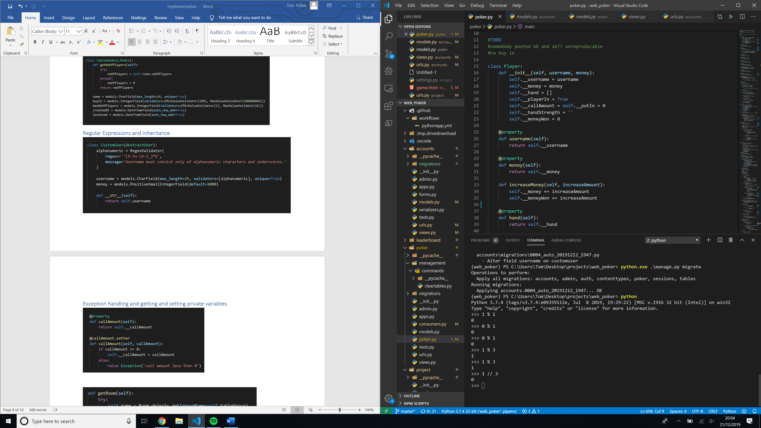

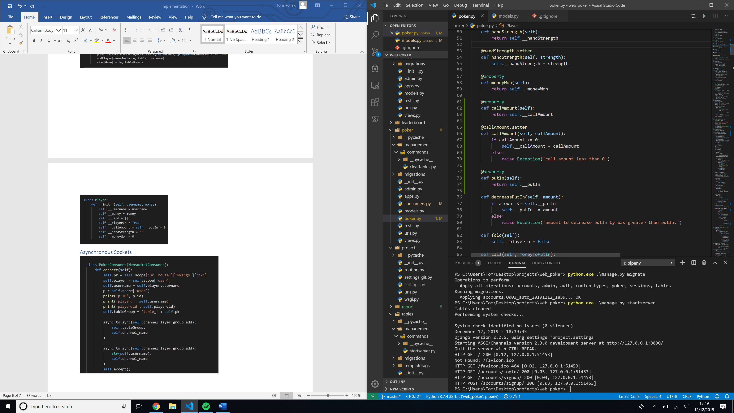

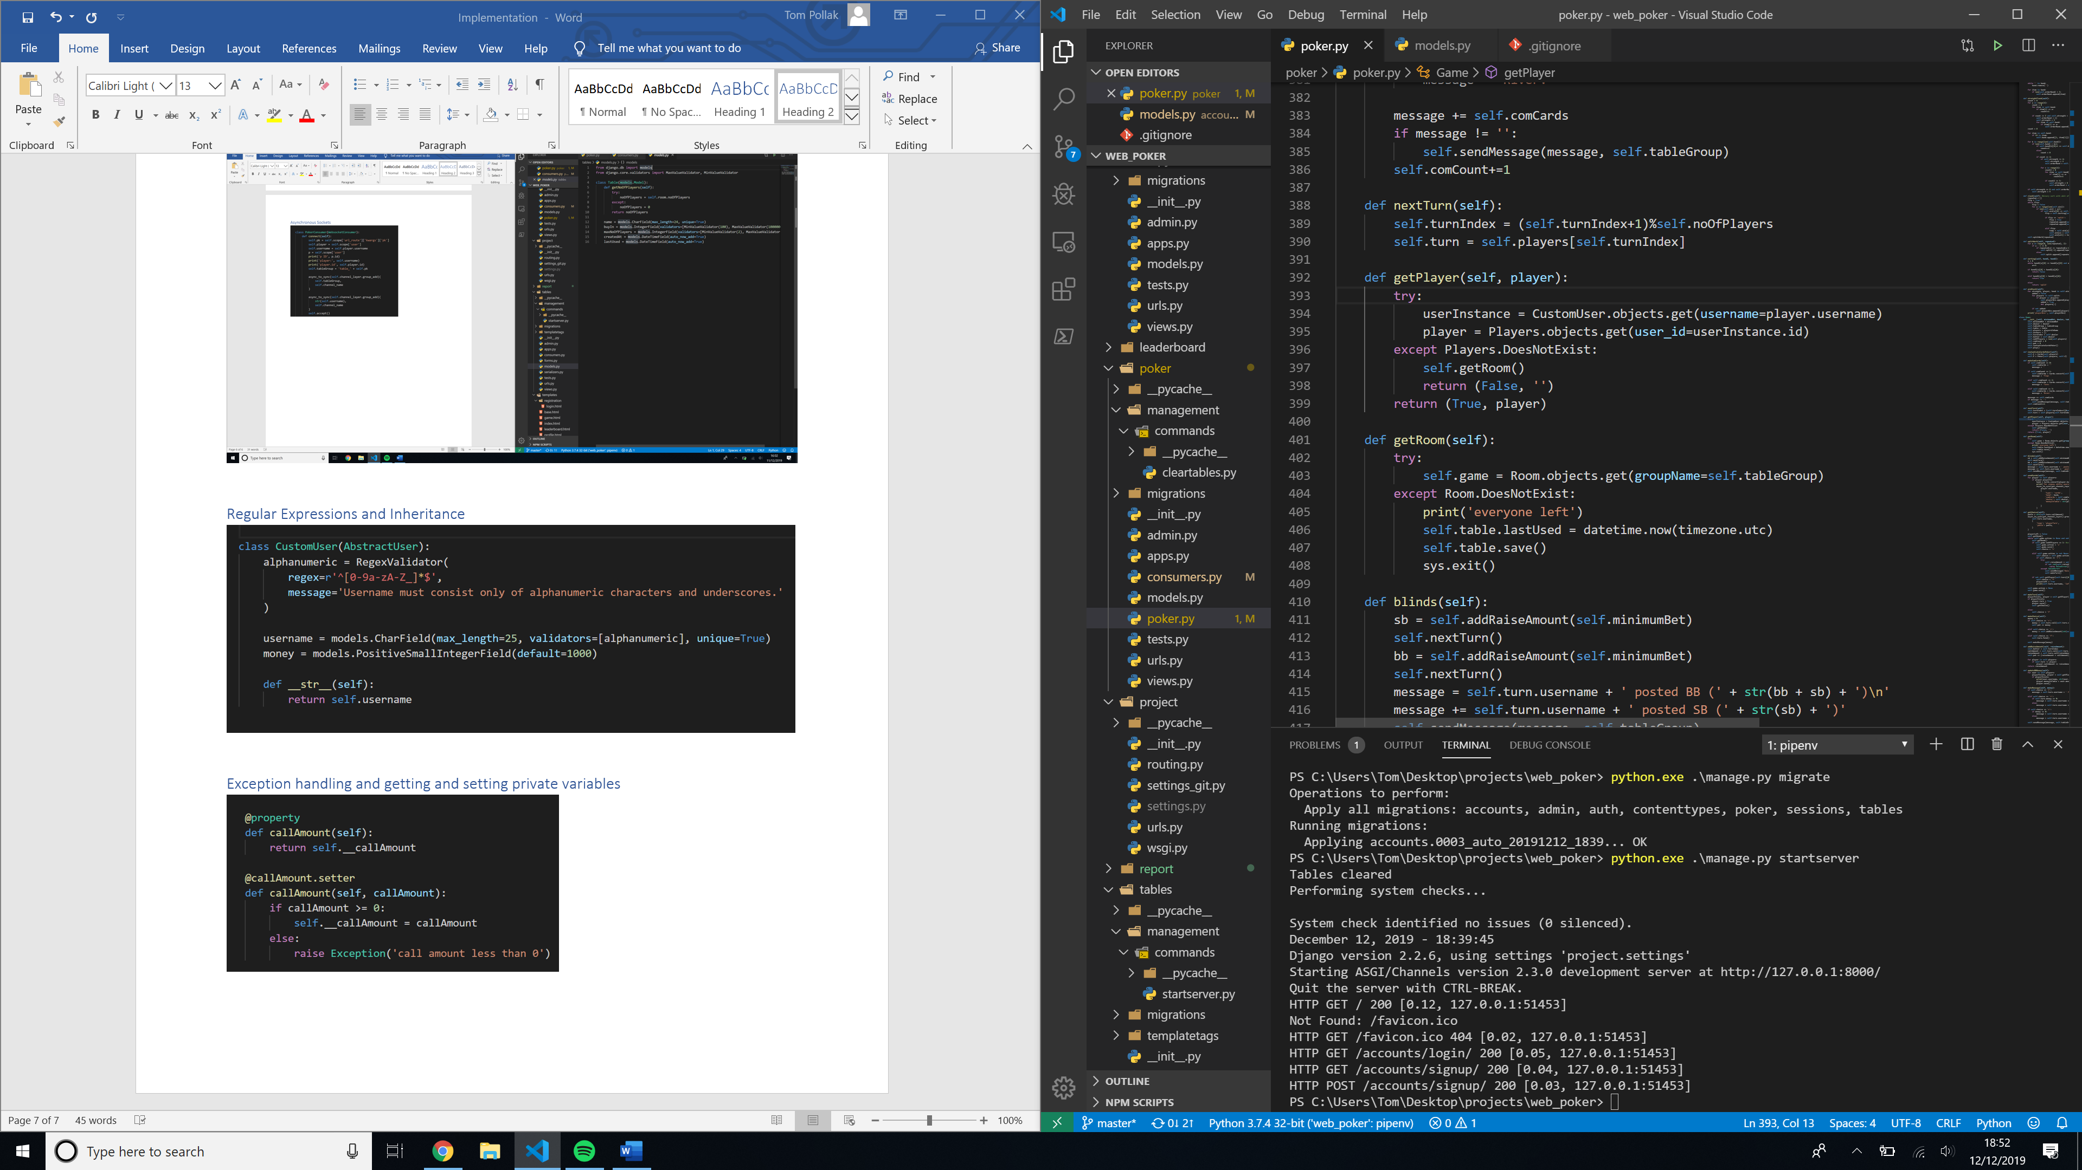

## Web requests

### Form POST request and GET request when getting form

The create table uses a form modelled of the **Table** model. It uses the **Table** model to validate the form and the form can be saved as a **Table**. If the form is invalid the form in the POST will contain the errors in the form that can be passed onto the user, e.g. password must be more than 8 characters.

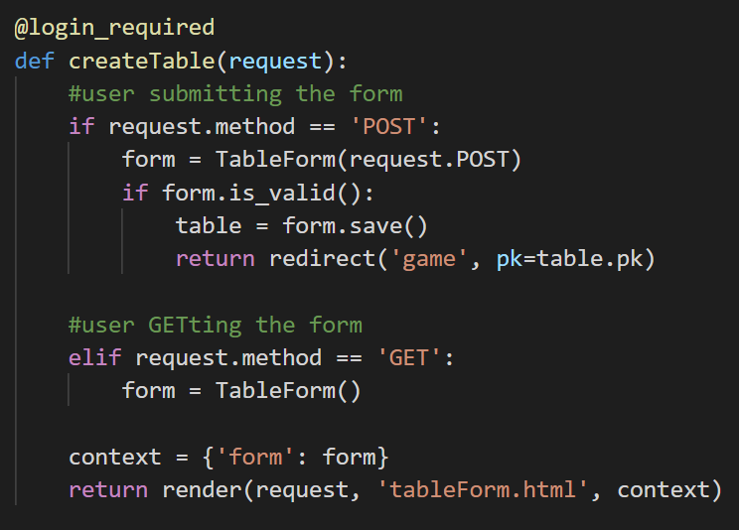

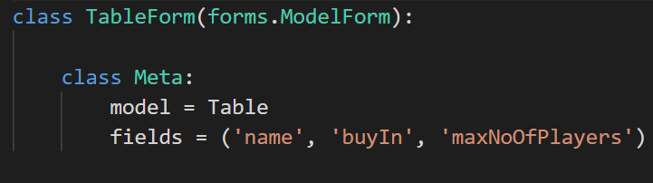

## Serializing DB object into JSON using RESTful API

To monitor the number of players in each table and the tables available live, I used Django REST framework to serialize the DB objects into JSON format to pass to the JavaScript by sockets

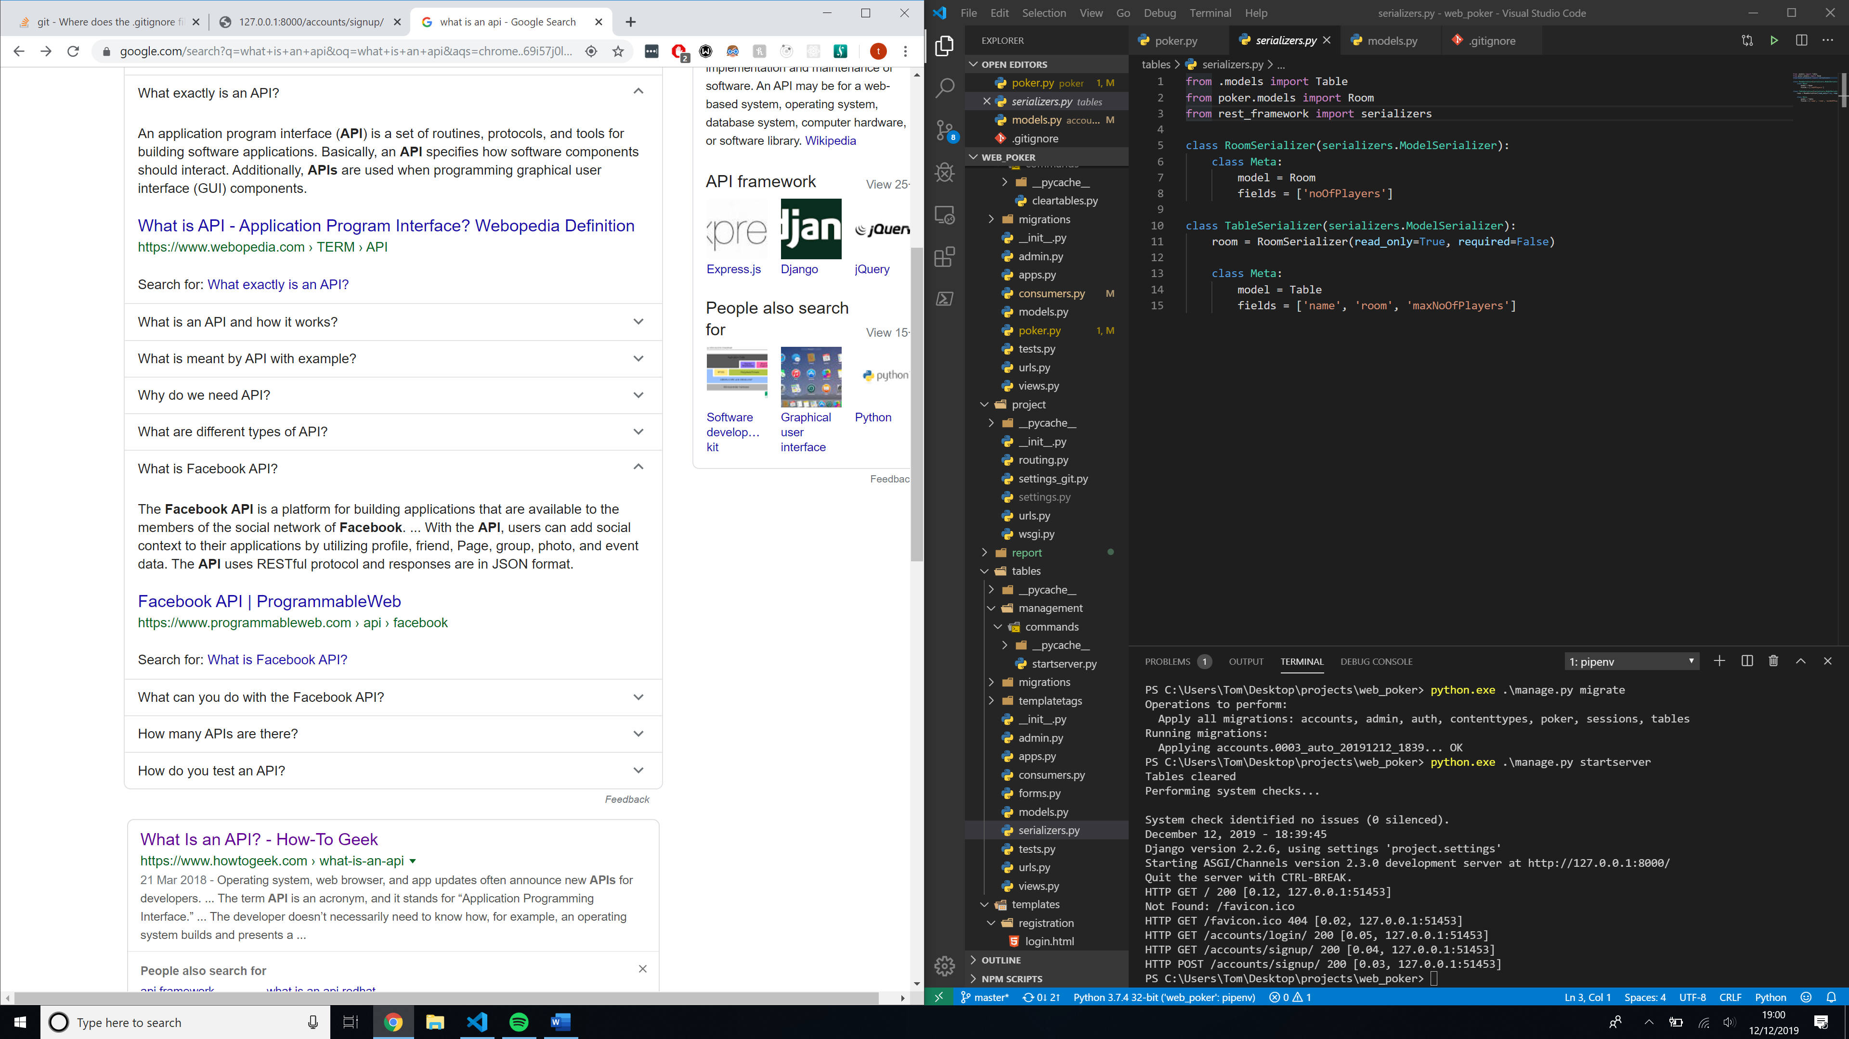

### Creating and using serialized data in conjunction with web sockets

The table gets the

